

By: Yasmine BOUCHAREB 66913

Supervisor: Milos VULANOVIC

Msc Management studies

May 2020

EDHEC Business School does not express approval or disapproval concerning the opinions given in this paper which are the sole responsibility of the author.

I certify that: the master project being submitted for examination is my own research, the data and results presented are genuine and actually obtained by me during the conduct of the research and that I have properly acknowledged using parenthetical indications and a full bibliography all areas where I have drawn on the work, ideas and results of others and that the master project has not been presented to any other examination committee before and has not been published before.

*Master thesis: country development*

How do governmental policies impact the progress of developing countries?

# Abstract

The world is changing and it is the only constant in life. New technologies are modifying our society, our daily lives. Companies and governments are investing a lot of money on artificial intelligence, and on infrastructures that will welcome those new technologies. However, as Solow explained in his paradox (Triplett, J. E. (1999). The Solow productivity paradox: what do computers do to productivity? *The Canadian Journal of Economics/Revue canadienne d'Economique*, *32*(2), 309-334), technologies don’t have a huge impact on the productivity, and therefore on the economy as the other industrial revolutions had.

If we also consider the fact that in 2006, the median household income (which separates the population into two groups) was lower in 1998, even if the GDP per capita increased by 9% during this period. And if we consider a longer period, 40 years from now, the median revenue increased by 30% while the GDP per capita doubled.

We can say that governments in order to increase the GDP, and the economy of their countries, have put in place policies with negative effects on the well-being of the population. Consequences that affected daily lives, capital (human, natural…), and all elements that constitutes our society. With the arrival of new technologies, we have to push governments to act differently, and create policies that will not only improve the economy, but also increase the well-being of the population.

Table of Contents

Abstract 1

Preface, problem statement 3

Part 1: literature review, theoretical framework, hypothesis 7

Economic investment and GDP 7

An alternative policy: Social investment and well-being 9

Positive association between social investment and well-being 10

The different types of social investments 11

Concrete example of policies with a positive consequence on citizen’ well-being 13

Part 2: description of methodology used, analysing, interpreting and reporting basic research results 15

Methodology used 15

Prerequisites 15

Quantitative survey, focus on the candidate experience 15

Individual situation and perception of life 21

Analysis of the variables 27

Part 3: Conclusion, recommendations and proposed solution 36

References: 38

Appendix 40

# Preface, problem statement

“Economic growth without investment in human developing is unsustainable and unethical” – Amartya Sen (Gopal, K., & D'Souza, N. (2018). Growth at What Cost? *NHRD Network Journal*, *11*(3), 103-106.)

Governments should implement more social policies in order to increase the well-being of the population. Indeed, during centuries, governments have focused their goals on economic growth putting aside the well-being of the population: how to improve the value of the goods and services produced by the country. There is a positive correlation between GDP and well-being that governments should develop with social policies.

Jean-Paul Fitoussi, Institut d’Etudes Politiques de Paris economics professor was explaining that an increase in road traffic would drive up oil consumption and lead to larger GDP numbers that obviously misrepresents the social wellbeing. (Stiglitz, J., Sen, A. K., & Fitoussi, J. P. (2009). The measurement of economic performance and social progress revisited: reflections and overview.)

We live in a world where competition is omnipresent. A race against investors, a race against exports, and a race against GDP has been crafted since neoliberalism when we discovered that competition increases production and represents a road to prosperity. But “growing GDP may have saved the economy, but it has done so at the expense of those the economy is meant to serve” (Caitlin Prowle, 8th July 2019, Domestic policy, Possibilities).

World Bank, with a measure of people who earn less than $1.25 a day, determined that the population of global poor is 1.44 billion people. The multinational Poverty Index (MPI), taking into account living standards, years of schooling, and other components, raises that number to 1.71 billion, according to Harvard magazine.

With a continuous growing power of GDP, governments have focused their guidance on how to increase this indicator to make their country wealthier leaving aside other programs for their population. Nonetheless, this approach has created consequences in the society.

GOVERNMENT

POLICIES

PROGRESS OF DEVELOPING COUNTRIES

INVESTORS AND INTERNATIONAL INSTITUTIONS WITH GDP CRITERIA + POLITICIANS AND THE ELECTION CYCLE

We can assume that governmental policies have an influence on our daily life, on everything we can achieve or can’t achieve even if they are controlled by external factors such as investors, international institutions… This master thesis will try to understand the impact governmental policies have on our lives, what policies contribute to our development and where governments should invest in order to increase the well-being of the population: The relation between governmental policies and country development.

**How do governmental policies impact the progress of developing countries?**

Governments have a public budget, coming from taxes and aids that they have to allocate in different sectors. The allocation is previously studied and determined according to different factors. Budget has to be given to needed sectors and to sectors with high return on investment. Budget also has to satisfy the different lobbies, the international allocation rules, the speech of the government elected with a specific mission and the population needs. The objective is to reach the short- and long-term goals of the country. Budgets are usually developed for 12 months period. When we observe data, we can see that the biggest part of the budget is allocated to the finance and defence sectors. Then health, education and other sectors (Appendix 3 and 4). This budget is used for many things but its main utilization is for investments: creation of infrastructures, investment in new technologies, and the purchase of materials.

All those policies have for ambition to increase the Gross Domestic Product (GDP).

# Part 1: literature review, theoretical framework, hypothesis

## Economic investment and GDP

According to Investopedia, Gross Domestic Product (GDP) is the total monetary or market value of all the finished goods and services produced within a country’s borders in a specific time period. As a broad measure of overall domestic production, it functions as a comprehensive scorecard of the country’s economic health.

To calculate the GDP, all the market values of products and services produced should be added, and the inflation rate should be subtracted to convert nominal values and real values. GDP use statistics to measure economic performance, and follow fluctuation of cycles. There are three official ways to measure GDP.

The first one is called the expenditure method. The formula known for GDP is the following: Household spending on goods and services + Gross investment + Government investment + government spending + (exports – imports).

The second is called factor incomes method. All incomes such as Wages and Salaries are counted, as well as incomes from the ownership of land. And profits of private sector businesses are added.

And finally, value of Output method: Value added from each of the main economic sectors (primary, secondary, tertiary).

Governments are interested in GDP because it is the most powerful economic indicator in the world. Each investor who wants to invest in a country, each international institution which wants to evaluate a country, uses the GDP as a reference. Therefore, countries must create policies that will generate an increase in the GDP.

Economic investment, better known as Foreign Direct Investment (FDI) has a positive impact on GDP, and on economy in general. An increase in FDI will create an increase in GDP growth because investors settled, participate in the improvement of the economy by hiring new people, by investing in infrastructures, by creating products and services, by exporting… (Appendix 6)

But the GDP does not necessarily fit to create good effects on the well-being of the population.

Nicolas Sarkozy, the previous president of the French republic said that GDP is effective in the measure of the market performance, but it can’t be associated to the well-being of the population. The indicator can’t explain the complexity of the society.

In fact, the GDP is considered as an indicator of economic performance as well as of the well-being of the population. Because it is the most powerful indicator, and because it is the reference to calculate the development of a country, GDP is also known as the symbol of the well-being. However, if we consider the computation of the GDP, we realize that some important points don’t fit to highlight the development of a country.

For example, Increasingly, we observe that people are more scared to go out, or to stay alone at home. Violence has increased in the society, and more people are sent into prisons. This phenomenon has created a public investment in prisons, in police officers, also in arms, which increased the GDP. It means that the economic performance increased, but social performance decreased. However, this investment has a positive impact of the GDP.

Moreover, if we take another example, in the health sector, GDP only considers the expenses. In the USA, health expenses are high and represented 15% of the GDP in 2008, compared to 11% of the GDP in France. However, statistics proved that infant mortality and life expectancy are low in the USA. Nonetheless, because GDP only includes the expenses, USA seem to be a healthy country.

If we think further and analyse how the GDP is calculated, we can say that some unfortunate events are value-added elements for the GDP. Indeed, if we imagine a government, which for no reason, decides to hire employees to destroy random buildings, and then hire other employees to reconstruct those buildings, the GDP will grow even if there were no purpose on doing this. Also, to be more accurate, if the bad state of roads increases, it will create more car accidents, which will increase the GDP because it increases the profit of car companies with automobile repair, and it increases health expenses.

At the opposite, factors offered freely by the government in order to improve the economy and the society, are not measured by the GDP and, thus, represent null value for the country. Investments done by public sector to increase the well-being of the population are not counted because they are public activities and not private activities.

Example, if in an economy, revenues are 100 and those people have a private health insurance that they pay 10, no taxes. We can say that at the end of the day final revenue is still 100, because health insurance reimburses for health issues.

If now people have revenue of 100, they don’t pay for a private health insurance but they pay 10 for taxes which include public health insurance that will reimburse health issues. But the final revenue is 90, because it is a public service.

As demonstrated, GDP is a good indicator, but it is not complete. It allows government to respond properly to the international economic expectations however it has an impact in the improvement of the well-being of the population.

## An alternative policy: Social investment and well-being

Statistics tell us the situation of the world. If we use statistics about indicators or public expenditures, we can know what are governments policies and where public investments are made. The first map we will be using represents the GDP (in %) of the world in 2019 from the World Bank (Appendix 1). The second map will represent the HDI (human development indicator) of the world 2017 from the World Bank (Appendix 2). The third map will represent the government expenditure on education, total (% of GDP) from UNESCO (Appendix 3). And the fourth and last map will represent the military expenditure (% of GDP) from UNESCO (Appendix 4).

If we compare the first two maps, we can observe that they are opposed: the countries with the highest GDP (in %) have the lowest HDI. The countries with the lowest GDP have the highest HDI. This finding indicates an issue. Subsequently, after looking at governmental policies (map 3 and 4), we can observe that countries invest way more in military than in education. Countries with the lowest HDI, prefer to invest a lot in military expenses than in education. Many governments invest less than 1.99% of their GDP in the education. After realizing this, we can wonder why? why do governments prefer to focus on the GDP than on HDI.

But what if we could prove that investing in the social could also increase the GDP. What if we could prove that investing in social and culture could attract investors, and increase FDI.

### Positive association between social investment and well-being

GDP and well-being of the population are highly correlated, in both ways. An increase in GDP, will thanks to the “trickle-down theory” make all “the society benefit from growth, and growth is most likely to come from those with the resources and skills to increase productive output” (Investopedia). And an increase in the well-being of the population, on their education, health, happiness… can improve the skills and productivity of the population, and then increase the GDP.

By focusing on GDP, governments have created policies with for only purpose to increase the indicator without knowing that an increase in the well-being of the population could also increase the GDP. In fact, if we look at the standard of living compared to the incomes and the cost of life, if we look at the quality of education, knowing that most pupils and students in developing countries are acquiring skills for jobs that won’t even exist in few years, if we look at the health of the population, living longer but with bad health, we start wondering if GDP is really the good indicator to calculate the development of a country. Many indicators such as HDI (human development indicator), MPI (the multidimensional poverty index), IHDI (inequality-adjusted Human development index), GII (the gender inequality index) … exist but none of them reach the GDP power.

“Health is an important form of human capital. It can enhance workers’ productivity by increasing their physical capacities, such as strength and endurance, as well as their mental capacities, such as cognitive functioning and reasoning ability. We expect to see a positive relationship between health and productivity for both unskilled and skilled workers.” (Harvard School of public health). The Asian model of development initiated in 1860s also proves that this theory works. Asian countries invested in their population, making the country fully educated, providing health care, nutritional support in a way that people are able to work productively according to Gandhi Rahul Model.

### The different types of social investments

Governmental policies have a big impact in our lives. They lead our society and control our behaviours. Therefore, they should be in the purpose of helping to increase the well-being of the population.

To calculate the well-being of the population the commission (Richesse des nations et bien-être des individus: Joseph Stiglitz, Amartya Sen, Jean-Paul Fitoussi) thought of three approaches: 1) psychology approach, subjective well-being notion, thinking that people are the best to determine what is good and what is bad. 2) capability approach, do people have the freedom to achieve things. 3) measurement of all non-market aspect of what creates well-being. (example: social connections, environmental conditions, insecurities of people, of the economy, have an impact in the quality of life). Inequalities in terms of quality of life: measure of individual inequalities and not average situation.

The big investment in education, in developing countries, should be in the post-graduation education, whereas the most important education is in early childhood. According to the world bank development report 2019, “from the prenatal period to 5, the brain’s ability to learn from experience is at its highest.” Students in developing countries acquire skills that won’t be useful for tomorrow’ jobs. Countries prefer to invest in quantitative schools to raise the GDP, instead of investing in a qualitative education that will prepare students for the future. A future lead by technologies while there are still people in developing countries who remain unconnected, with no access to internet (World bank development report 2019).

Indeed, quality of life depends on health, education, living conditions (right to a job, decent housing), participation in the political process, social environment, natural environment, and personal security and personal economic factors.

Therefore, to be able to create good indicators to improve quality of life, statistics should evaluate individual situations and inequalities. Then, they should create links between all aspects of quality of life, so governments will know where they should focus their attention. Because the consequence of each dimension goes beyond, it creates consequences on other dimensions. And finally, statistics should use those links to create group of dimensions.

A lot has to be done in order to improve the well-being of the population, including points highlighted above, as well as the population freedom and ability to act consciously (Amartya Sen Capability theory). Many institutions have worked to advise governments to reach an improvement of the well-being of their population. According to the HDI report 2018, the governmental plans should be focused on: socioeconomic sustainability, environmental sustainability, women’s empowerment, life-course gender gap, and quality of human development. According to the world bank development report 2019, governments should act in investing in human capital, particularly childhood education, to develop high-order cognitive and socio-behavioural skills in addition to foundational skills and they should also act on enhancing social protection: a solid guaranteed social minimum and strengthened social insurance, complemented by reforms in labour market rules.

The consultancy agency, Boston Consulting Group, also worked in this topic, and proposed the Sustainable Economic Development Assessment (SEDA) to measure well-being. Below is a graph showing the different dimensions of SEDA. (Appendix 5)

This study done by BCG has been tested on several countries like Rwanda for example (which is the African model of success, the African Singapore as called by the newspapers) where BCG has implemented its strategy in order to improve their performance in each sector. BCG was settled in Rwanda from November 2017 to November 2018. If we look at the results, the SEDA score of Rwanda went from 34.25 in 2016 to 36.41 in 2018 and 37.09 in 2019. Their Wealth-to-well-being Coefficient went from 0.99 in 2016 to 1.05 in 2018 and 1.07 in 2019.

Several countries are now interested in investing in the well-being of their population such as the United Kingdom and New Zeeland. We will be able to evaluate their progress, see if there is effectively a correlation between well-being and GDP, and answer the question: Are government policies responsible of the progress of developing countries.

There is also a theory called: bottom of the pyramid theory explains that instead of giving aids to developing countries, we should help the population increase its skills to become entrepreneurs. In fact, imports are expensive and they, sometimes, don’t respond to the population needs, or just create substitute offers. The theory explains that instead of doing philanthropy, we can invest on helping people develop their human capital, and we can invest on microcredits to help them create their own business models.

### Concrete example of policies with a positive consequence on citizen’ well-being

Governmental policies focusing on quality of life will improve citizen’ well-being. The theory of Esther Duflo, Abhijit Benerjee justify it. They suggest verifying which governmental politics are working, and which ones are having the biggest impact on the population’s lives, they did social experiences to fight poverty. Small experiences could solve a lot of problems. Testing the theories and explaining to people why they should act in certain ways could change things and improve the well-being of the population. For instance, if governments in Africa were giving free bed nets to the population in order to get protected from mosquitos and therefore from the Malaria, more people would use bed nets. (Appendix 7) Also, if governments would invest on spreading information to make people aware of the positive consequences of putting their kids into schools, people would be more likely to do so. (Appendix 8) Esther Duflo and Abhijit Benerjee showed that governmental policies with positive consequences on the well-being of the population fit with the population’ needs. Governments should find solutions according to the country’s issues and culture.

# Part 2: description of methodology used, analysing, interpreting and reporting basic research results

## Methodology used

The overall approach to the research I have decided to use is the quantitative method, a survey, as it is the best for measuring and identifying patterns. I have decided to post the survey online, as I wanted everyone to be able to answer, with no preferences. The questions of the survey have been prepared in a way that respondents could give subjective and objective answers and guide us on the understanding of how governments policies are settled and perceived in different countries.

## Prerequisites

In order to answer the problematic question, and understand the thoughts of the world population, this survey underline the importance of the population’s perception on the politics driver by governments. Starting from the observation that the field of study is vast, the survey will focus on the following aspects:

* The identification of the different politics settled in different countries, according to the respondents
* The connection between what politics have been identified and the politics that the respondents want to have in their countries
* The construction of an indicator that will improve the development economics of different developing countries.

## Quantitative survey, focus on the candidate experience

In order to complete our preliminary study consisting of a collection of opinions, computing the understanding of the population’s view of the government policies.

The population studies are made up of people from different countries, with different backgrounds, ages…From this population, a sample of 50 individuals was drawn up to be surveyed.

In this survey, these specified are the following:

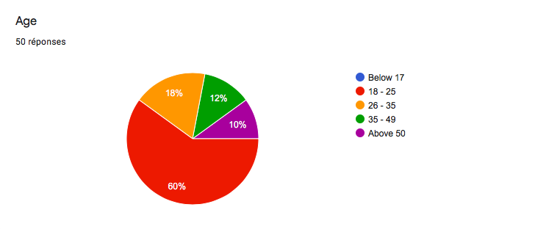

60% of respondents are between 18 and 25 years old, 18% are between 26 and 35, 12% between 35 to 49 and 10% above 50 years old.

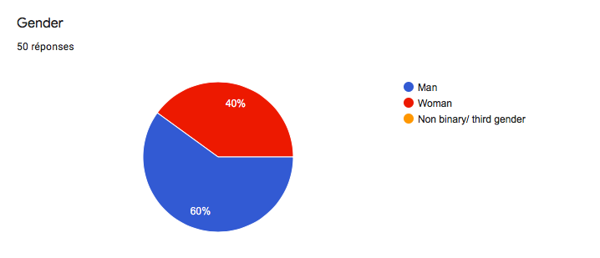

60% of the respondents are men, 40% women.

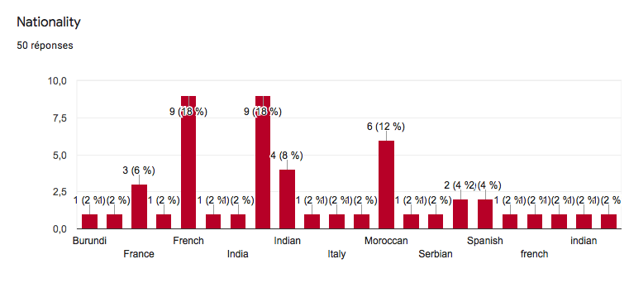

The respondents come from different countries such as Burundi, France or India.

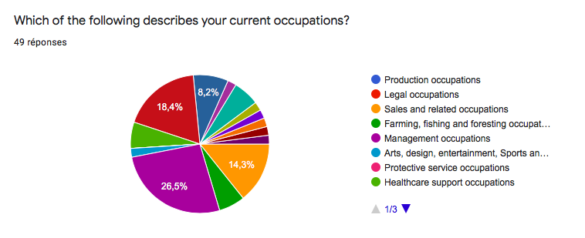

The respondents have different backgrounds such as 26,5% in Management field, 18,4% in law field, 14,3% Sales field.

On the other hand, the choice of the number of questions must be made according to the amount of information to be collected, the degree of precision desired and the estimated time for responding to the questionnaire. Our collection strategy will therefore focus more on a short questionnaire comprising 10 questions, including signage questions, to ensure that we have a satisfactory response rate. In fact, the target population is only made up of profiles who have very limited time for additional activities and who are easily put off by an approach exceeding 5 minutes. This is why we will focus our questionnaire on a majority of questions offering multiple choices, rankings, scales in order to promote a fun aspect but to integrate an option of obligation to answer all the questions. Particularly to the last question which is open will constitute a first qualitative contribution directly targeting the subject of our study.

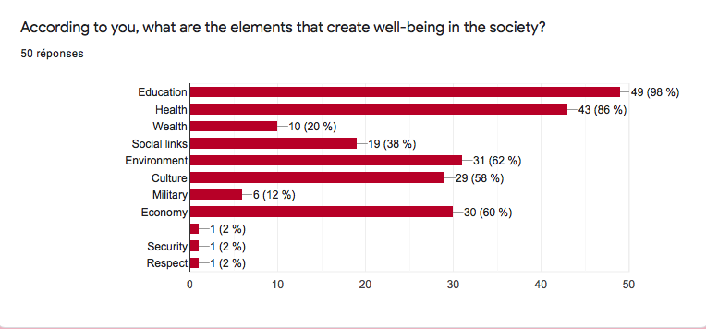

This first question, a multiple choices question, has for purpose to identify the first opinion of the respondents about the subject.

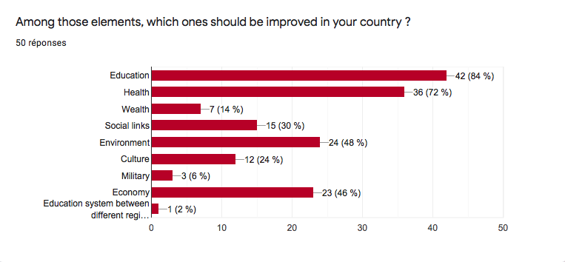

The second question is a multiple choices question. It identifies the individual situation of each respondent. According to their personal and professional experience in their respective country, they can answer the question subjectively.

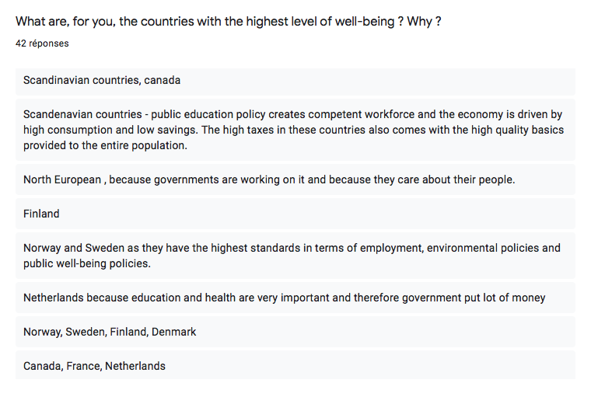

This question is an open question to respondents coming from different part of the world, trying to identify their perception of the “utopian” country according to their nationalities.

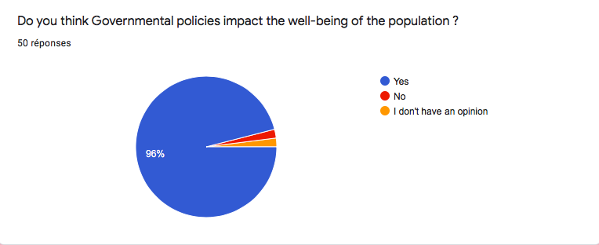

This question represents the heart of the survey. It symbolizes the main point to underline.

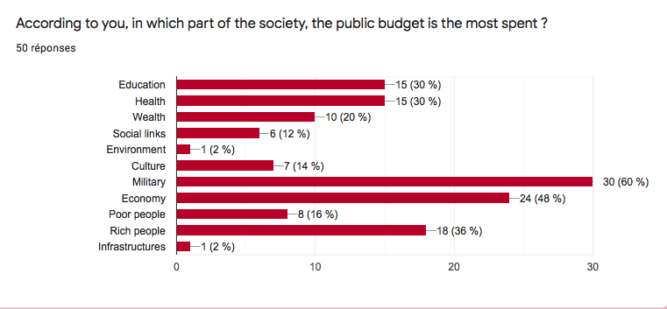

This question is a multiple choices question. It is a primarily question introducing the next question. It is useful for the respondent to take position in the survey, and give his opinion. Therefore, asking a primarily question asking for an objective answer introduce the second question asking for a subjective answer.

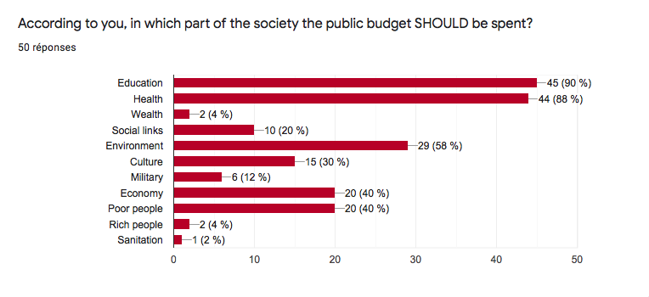

In this “second” question, the respondent is more willing to give a subjective answer.

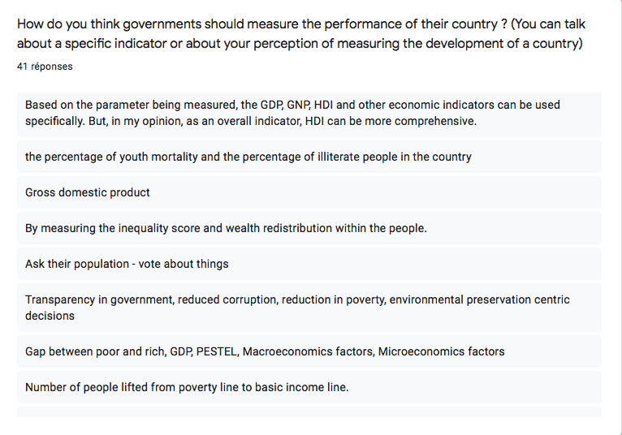

This last question is an open question that has two goals:

* Summarizing the whole opinion of the respondent
* Going concrete advices concerning the measurement of the well-being of the population.

### Individual situation and perception of life

**Question 1: According to you, what are the elements that create well-being in the society?**

*Results: Education 98%, Health 86%, Environment 62%, Economy 60%, Culture 58%*

* The respondents had different choices that can be put in two categories: economic concepts, social concepts. We can observe that the population considers that social concepts are more willing to create well-being in the society, but without forgetting economic concepts that allow the settlement of social policies.

**Question 2: Among those elements, which ones should be improved in your country?**

*Results: Education 84%, Health 72%, Environment 48%, Economy 46%*

* The respondents believe that, in their countries, the basis of social concepts should be improved (education, health) as a priority, and then environment and economy.

Military and wealth represent 5.9% and 15.7% respectively.

**Question 3: What are, for you, the countries with the highest level of well-being? Why?**

Scandinavian 50%, (gender equity, stable economy, good relations with everyone, Norway and Sweden as they have the highest standards of employment, environmental policies and public well-being policies; they are advanced countries in terms of happiness, balance professional life/ personal life, ecology; public education policy creates competent workforce and the economy is driven by high consumption and low savings. The high taxes in these countries also comes with the high-quality basics provided to the entire population; basic social needs are covered and disparities are limited in order to create a cohesion and equal opportunity; education and health are very important and therefore government put lot of money; because the social security system in these countries is very strong; good level of well-being in terms of happiness of the people, Danish are highly rated though the weather because of well-functioning of economy, social links, wealth and schools. Denmark, if well-being is synonymous with the perception of happiness then Denmark is ranked 1st with the largest proportion of its inhabitants claiming they perceive themselves as happy; governments are working on it and because they care about their people; government is handling correctly all those rescues while the citizens pay correctly their taxes.)

Luxembourg (4 answers): government financially covers many “basic” public services (i.e. free public transports;

Bhutan (2 answers): because of the way they pioneered gross national happiness, for maintaining peace in this otherwise chaotic world, for their economy and also Canada for being so secular and accepting of all kinds of people and for the opportunities they have for immigrants to start a new life and also for the way they’re tackling gender equality issues; social security system in this country is very strong

USA (1 answer): because government is providing lot of benefits like funding, research permissions, mainly in education sector.

Qatar (1 answer): it’s economically well off and the people there live a luxurious life. With good education and always in touch with their culture.

* If we analyse the different answers given by the respondents, we can observe that the criteria highlighted are gender equity, stable economy, diplomacy, environment, security. A government which implements economic policies in order to create wealth, high standards of living, but also social policies in order to make people’s life more pleasant, more rewarding in a sustainable way.

**Question 4: Do you think governmental policies impact the well-being of the population?**

96% yes

* The respondents are aware that their personal well-being depends on governmental policies. They know that in function of who they elect, what the government decide to implement, their life will change in a better or worse way.

**Question 5: According to you, in which part of the society, the public budget is the most spent?**

Military (60%), economy (48%), rich people (36%)

* According to the respondents, governments spend more money on “economic” policies than on social policies.

**Question 6: According to you, in which part of the society the public budget should be spent?**

Education (90%), health (88%), environment (58%), economy (40%), poor people (40%)

* According to the respondents, governments should spend more money on social policies in order to help the population live a more comfortable life.

**Question 7: How do you think governments should measure the performance of their country? (you can talk about a specific indicator or about your perception of measuring the development of a country)**

* HDI (2
* GDP (4
* Wealth distribution per capita and Gini index
* NRC
* Life expectancy and environment
* based on the parameter being measured, the GDP, GNP, HDI and other economic indicators can be used specifically. But, in my opinion, as an overall indicator, HDI can be more comprehensive
* the percentage of youth mortality and the percentage of illiterate people in the country
* measuring the inequality score and wealth redistribution within in the country
* Ask their population – vote about things
* Transparency in government, reduced corruption, reduction in poverty, environmental preservation centric decisions
* Gap between poor and rich, PESTEL, macroeconomics factors, microeconomics factors
* Number of people lifted from poverty line to basic income line
* Focus on what the population want and need
* Index that includes health and education
* Literacy levels, employment rate, happiness index, climate index, GDP per capita
* Health and happiness indicator
* Health and education parameters of the country
* Level of education and state of mind
* Through environmental performance
* Literacy rate & health rate
* Foreign investments, GDP/inhab
* Educational level, quality of hospitals, public transportation, public services and social services
* Government should be constantly watching the happiness of their citizens
* By their literacy rate growth, their economic turnover, GDP and also the rate for unemployment
* Illiteracy and social inclusion rates
* Average wage per capita and wealth concentration index
* Economy and health country
* Amartya Sen theories
* Measure the development of a country, governments should study what medium/low class are doing to live or survive
* Economy and social relations of the country
* Health, wealth and the social dynamics
* Development is usually measured by GDP, which is generally about the economy but it’s a good performance indicator.

If we explore the different answers we can find different conclusions:

* People are interested in comparing economic indicators and social indicators.
* The respondents want governments to ask the population what it wants and needs to implement new policies according to the population’s wishes.
* People are looking to get a better life, but also reduce inequalities and think of a sustainable way to get wealthier.

### Analysis of the variables

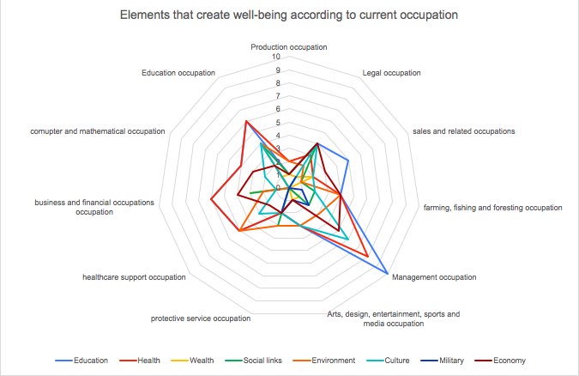

This graph represents the answers of the respondents on the elements that create well-being in the society. I have decided to analyse their answers according to their current occupation because the survey is subjective. Respondents used their personal knowledge acquired in their personal and professional lives.

The graph gets in shape the number of respondents in each occupation and their answers. We can observe that Education, Health and Environment are the most chosen criteria. People working in management think that education and health are the key to reach well-being.

People working in healthcare support think that health and environment are the key.

People working in education think that education and health are the key.

Other criteria such as culture, social links and economy are an important part of the answers. For people working in the law sector, education and economy are key to reach well-being.

The answers match with the current occupation of the respondent. Someone working in management will think that education and health are key to access bell-being, because those two elements increase the productivity within the company. Someone working in healthcare support will think that health and environment are key because there are the two elements that improve the health of individuals.

The important element to highlight here is that all elements are important and create well-being. According to people’s personal and professional lives, different elements are the priority, but if we gather all the backgrounds we can say that all elements create well-being for some categories of people. Which means that in developing countries, governments should focus on the economy which is one of the most important element to make a country survive, but education, health, social links, culture and environment should not come second. Those elements should also be the priority of governments as they increase the productivity, and the well-being of people.

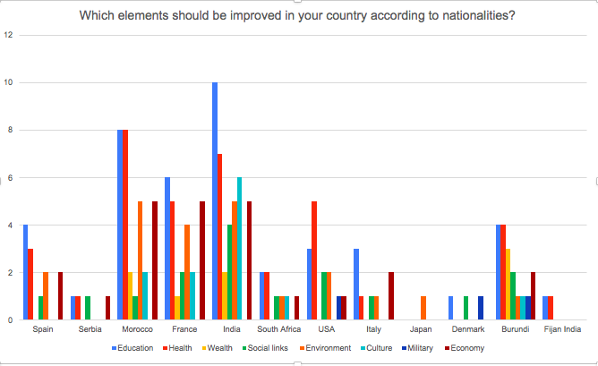

On this graph, we can observe the answers of the respondents about the elements that should be improved in their country according to their origin country.

This graph is important because it allows us to identify the absent elements in each country according to its population.

The first observation we can see is that education and health are missing elements in many countries according to its population.

In Spain, the elements that should be improved are Education first, Health second and environment third

In Morocco it is Education first, Health second, and environment and economy third.

In India it is education first, heath second, and culture third.

From what I can understand from this graph, People even from developed countries such as the US, think that Education and health should be improved. Then other elements depending on each country such as environment and economy should also be improved.

But education and health are the key to economic growth. They are two basic elements that should be functional in each country in order to invest in sectors with higher profit later.

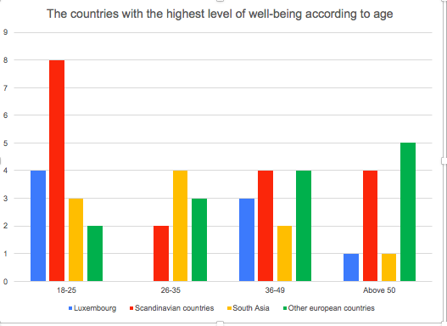

In this graph, respondents are placed in age categories: 18-25; 26-35; 36-49; and above 50. They have been asked about their subjective opinion on the countries with the highest level of well-being.

This question is important because it will help determine the significant elements that people consider as generator of well-being and compare it with the first question.

We can first see that the four response categories chosen by the respondents are Luxembourg, Scandinavian countries, south Asia and other European countries. All those countries have chosen to focus on education and health in order to improve their economy. They are successful growth countries because governments have decided to invest first on the population in order to get them qualified and then invest on the economy and the different business sectors.

For people, around 18-25 years old Scandinavian countries are the model of well-being. From the explanation of answers given by the respondents on this question, I can explain their choice by the fact that in Scandinavian countries, people come first. The well-being of each individual is more important that the enrichment of the country itself. However, this policy increases the well-being of the population as well as the enrichment of the country.

For people around 26-35 years old, South Asian countries are the model of well-being. This choice can be explained by the fact that governments on those countries have decided to invest in each sector: education, health, culture, economy, military… In order to rank their country in a higher position. Each element is good to reach this goal. This strategy has allowed those counties to increase their economic growth by focusing on their population and on specific sectors with high profitability. Respondents from this category explained in their answer that countries should focus on a limited number of sectors, but also on education and health, in order to create specific skills that will increase the productivity in those specific sectors and rise the growth.

For people around 36-49 years old, European countries in general are the countries with the highest level of well-being as they are growing in harmony with their population. The economic growth as well as the personal growth of the population is increasing at the same rate.

For people above 50, European countries excluding Scandinavian countries and Luxembourg are the countries with the highest level of well-being as their natural resources are limited and they could register high economic growth. Governments should find ways to improve their economy and the personal growth of their population according to what they are good at.

From all those comments coming from the respondents, we can say that what is most important for people is governments who are aware of their economic and social situation and work for it, in harmony, in order to increase the growth of both sectors.

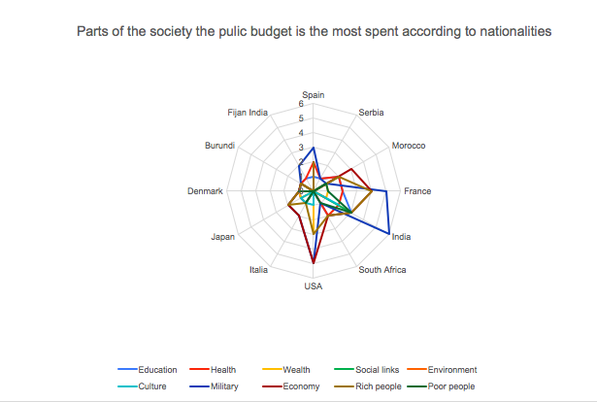

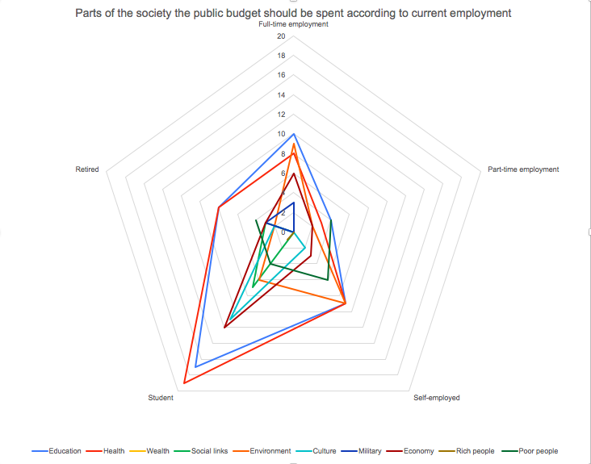

Those two graphs are complementary. The first graph shows parts of the society in which the public budget is the most spent according to nationalities. It allows us to identify the sectors where governments invest most of its money according to people coming from different countries, but it also allows us to recognize the perception of the respondents on sectors that seem to be more developed than others.

The second graph shows the part of the society in which governments should invest more according to the current employment of the respondents. This graph is also linked to the second graph explained above. It allows us to find out, according to the point of view of people from different backgrounds, what are the sectors where the population does not feel the improvement.

From the first graph, we can observe that Military, economy, and rich people are the concepts where government invest the most in according to people coming from India, Morocco, France, Spain, Japan and USA. Concepts such as education, health, and environment that seem to be important for people as reported in previous graphs, are not perceived as a priority for governments to invest in.

In the second graph, we can see that Health, education and environment are, according to the respondents, the sectors where governments should spend more of the public budget in. For people working in part-time employment spending the public budget on poor people is also a priority.

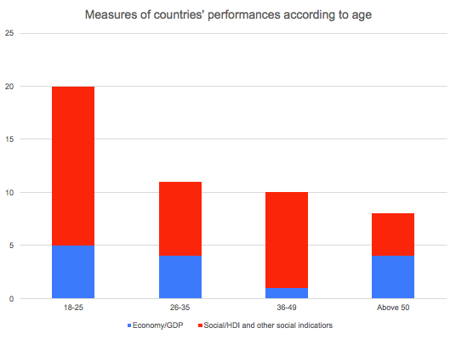

This last but not least graph highlights the opinion of the respondents on the measures that would be most effective in order to estimate countries’ performances. As shown above, 98,1% of the respondents explained that governmental policies impact the well-being of the population.

We can clearly recognize that for 18-25, 26-49 and 36-49 categories, social indicators should be prioritized. For the respondents above 50 Economic as well as social indicators should be used to measure the performance of governments.

The respondents explained in their answers that high social indicators automatically show high economic indicators; but high economic indicators do not imply high social indicators.

# Part 3: Conclusion, recommendations and proposed solution

Governmental policies have a colossal impact on the well-being of the population. They determine our future and limit our progression. The quality of our lives has to do with our personal decisions but also with the way governments decide to allocate their budget. If a government decide to assign a big part of its budget on the military sector, and a small part of it on the health sector, how would workers be productive? What if they get sick, how much time will they need to heal with a poor health system?

Governments have for a long time focused their attention on the GDP, trying to invest in sectors with a high return on investment, sectors that would increase the GDP. For that, they have put in place policies that have created unbalanced economies. Rich people are getting richer while poor people are getting poorer. Finance and military sectors are getting improved while health and education sectors are decaying. GDP is a good economic indicator which has allowed countries to get developed in order to appeal foreign investments as GDP is the main attraction point. However, GDP does not necessarily fit to develop the well-being of the population. Indeed, countries with highest GDP (in %) have the lowest HDI.

As economy and social and correlated and if combined they allow a sustainable improvement of countries, governments should implement policies for the people, policies with good impact on people’s lives as it will automatically generate a development of the economy. Quality of life depends on health, education, living condition, participation in the political process, social environment, natural environment, personal security, personal economic factors and freedom and ability to act consciously. To develop those elements, governments should start by analysing their population: What are the individual situation of each, what are the elements that should be improved and the elements that create added-value. Data is the main point to create new policies. A good data base is mandatory to understand a country and its specificities. Each situation is important to take into account in order to compare people with same wages, same backgrounds and same environment and compare their progression. Statistics should evaluate individual situations and inequalities. Governmental policies focusing on quality of life will improve citizen’ well-being. Each country is different, and each country needs a different strategy in order to improve the well-being as well as the general economy. Governmental policies have to be designed for the population. That’s the key to success and development. Governments should find solutions according to the country’s issues and culture and for that, as Esther Duflo explained, theories should be tested and explained to the population in order to make them realize the importance of following the policies implemented for them. There is no perfect model, or perfect policy that will generate development. Only concepts that have to be tested and sectors that have to be regulated according to each country’s population.

Now, different elements have to be wondered:

The efficiency and the relevance of the policies: Do all countries have the capacity to gather data and implement good policies for their population?

The aids and countries’ loans: Bottom of the pyramid theory: Can we make the population entrepreneurs if each policy has to be specific to each country? Do aids be given even if they were proven to be inefficient?

The regulation of those policies: how do international organizations judge and evaluate the policies of each country if there is no model example?

# References

* Sen, A. (1999). Commodities and capabilities. *OUP Catalogue*.
* Nussbaum, M. C. (2011). *Creating capabilities*. Harvard University Press.
* United Nations Development Programme. (2018). Human development indices and indicators: 2018 Statistical update.

* Stromquist, N. P. (2019). World Development Report 2019: The changing nature of work.
* Fikre, B. M. (2011). The Politics Underpinning the Non-realisation of the Right to Development. *Mizan Law Review*, *5*(2), 246-263.
* Boston Consulting Group website – SEDA: An interactive Guide
* The World Bank – Data
* Saito, M. (2003). Amartya Sen's capability approach to education: A critical exploration. *Journal of philosophy of education*, *37*(1), 17-33.
* Costanza, R., Hart, M., Kubiszewski, I., & Talberth, J. (2014). A short history of GDP: Moving towards better measures of human well-being. *Solutions*, *5*(1), 91-97.
* The guardian – Labour to propose new wellbeing law to inform policy decisions
* Stiglitz, J., Sen, A., & Fitoussi, J. P. (2009). *Richesse des nations et bien-être des individus.: Performances économiques et progrès social*. Odile Jacob.
* Banerjee, A. V., Banerjee, A., & Duflo, E. (2011). *Poor economics: A radical rethinking of the way to fight global poverty*. Public Affairs.
* Pinker, S. (2018). *Enlightenment now: The case for reason, science, humanism, and progress*. Penguin.

# Appendix